

PRESENTATION SCHEDULE
Riders are to be dressed in competition attire for presentations. All presentations are unmounted. Horses & ponies are required straight after presentation for photos with rug if they win champion or some special classes listed below. We cannot post your prizes to you so if you are unable to attend presentation please arrange someone else to collect your rosettes and prizes. Times are subject to change, so check notice board and listen for announcements.
FRIDAY 12th APRIL | 5:30 PM
Britt Grovenor Photgraphy CU Preparatory 1 | 1st- 8th
Khonkes Own CU Preparatory 2 | 1st- 8th
Black Horse Manor CU Preparatory Championship | Chp & Res | Champion horse required
Equine Supergoo CU Novice 2.1 - Horse | 1st- 8th
Eq Saddlery CU Novice 2.2 - Horse | 1st- 8th
Nutrien Yass CU Novice Championship | Chp & Res | Champion horse required
Eq Saddlery CU Novice 2.1 - Pony | 1st- 8th
Huds & Toke CU Novice 2.2 - Pony | 1st- 8th
Bluefields Saddlery CU Novice Pony Champ | Chp & Res | Champion pony required
Megan Bryant Equestrian CU Young Rider Preparatory 1 | 1st- 8th | All riders receive a Prize
Huds & Toke CU Young Rider Preliminary 1.1 | 1st- 8th | All riders receive a Prize
EQ Saddlery CU Young Rider Preliminary 1.2 | 1st- 8th | All riders receive a Prize
Megan Bryant Equestrian CU Young Rider Novice 2.1 | 1st- 8th
Megan Bryant Equestrian CU Young Rider Championship | Chp & Res | Champion horse required
Langfield Haulage Equibility AW-1 | 1st
Langfields Haulage Equibility AW-1 | 1st
Langfield Haulage Para Equestrian Champion | Chp | Champion horse required
Equinade Preliminary 1.2 - Open | 1st- 8th
Equinade Preliminary 1.3 - Open | 1st- 8th
Equinade Preliminary Championship | Chp & Res | Champion horse required
Britt Grovenor Photography Preliminary 1.2 - Pony | 1st- 8th
Bryants Hay Preliminary 1.3 - Pony | 1st- 8th
Britt Grovenor Photo Preliminary Pony Championship | Chp & Res | Champion pony required
Heiniger Advanced 5.2 - Open | 1st- 8th
Dressage Plus Advanced 5.3 Open | 1st- 8th
Donges IGA Advanced Championship | Chp & Res | Champion horse required
Bryants Hay Advanced 5.2 - Pony | 1st- 8th
Bryants Hay Advanced 5.3 - Pony | 1st- 8th
Lark Hill Winery Advanced Pony Champion | Chp & Res | Champion pony required
Jenquine Advanced 5.2 - AOR | 1st- 8th
Jenquine Advanced 5.3 -AOR | 1st- 8th
WOW Saddles Australia Advanced AOR Champion | Chp & Res | Champion horse required
Heiniger Advanced 5.2 - Young Rider | 1st- 8th
Conquerer Milling Advanced 5.3 - Young Rider | 1st- 8th
Horsezone Advanced Young Rider Champion | Chp & Res | Champion horse required
Kim Lang Exhibition Freestyles |  | All riders receive a prize
Kim Lang CU Freestyles (Prelim – Grand Prix) | 1st- 8th | Placed in each level
Kim Lang Pas de Deux | 1st - 2nd

SATURDAY 13th APRIL | 5:30 PM
Voler Equestrian CU Rider Limited Preliminary 1.1 | 1st- 8th
Stance Equitec CU Breed Limited Novice 2.2 | 1st- 8th
Horseland Saddlery Preliminary 1.2 - AOR | 1st- 8th
Horseland Saddlery Preliminary 1.3 - AOR | 1st- 8th
Horseland Fyshwick Preliminary AOR Champion | Chp & Res | Champion horse required
Voler Equestrian Preliminary 1.2 - YR | 1st- 8th
Huds & Toke Preliminary 1.3 - YR | 1st- 8th
Voler Equestrian Preliminary YR Champion | Chp & Res | Champion horse required
Canowindra Produce Novice 2.2 - Open | 1st- 8th
Conquerer Milling Novice 2.3 - Open | 1st- 8th
Gladiator Floats Novice Championship | Chp & Res | Champion horse required
Equinade Novice 2.2 - Pony | 1st- 8th
Equinade Novice 2.3 - Pony | 1st- 8th
Colonial Motel Young Novice Pony Champion | Chp & Res | Champion pony required
Voler Equestrian Elementary 3.2 - AOR | 1st- 8th
Riverina Stockfeed Elementary 3.3 - AOR | 1st- 8th
Voler Equestrian Elementary AOR Champion | Chp & Res | Champion horse required
Megan Bryant Equestrian Elementary 3.2 - YR | 1st- 8th
EQ Saddlery Elementary 3.3 - YR | 1st- 8th
Megan Bryant Equestrian Elementary YR Champion | Chp & Res | Champion horse required
Horses at Home Medium 4.2 - Open | 1st- 8th
Flexible Fit Medium 4.3 - Open | 1st- 8th
Emcee Apparel Medium Championship | Chp & Res | Champion horse required
Massage by Marylouise Medium 4.2 - Pony | 1st- 8th
Stance Equitec Medium 4.3 - Pony | 1st- 8th
Lark Hill Winery Medium Pony Championship | Chp & Res | Champion pony required
Khonkes Own FEI Prix St Georges | 1st- 8th | 1st - 3rd AOR, Pony, YR
McDowells Herbs FEI Intermediate A | 1st- 8th | 1st - 3rd AOR, Pony, YR
Riverine Stockfeed FEI Intermediate II | 1st- 8th | 1st - 3rd AOR & 1st Pony
Kim Lang Best Freestyle Costume | Winner

Happy Hour
Join us on Friday and Saturday evenings for happy hour prior to the evenings presentations. With complimentary wines from Diamond Sponsor Lark Hill plus nibbles from our naming rights sponsor Donges IGA
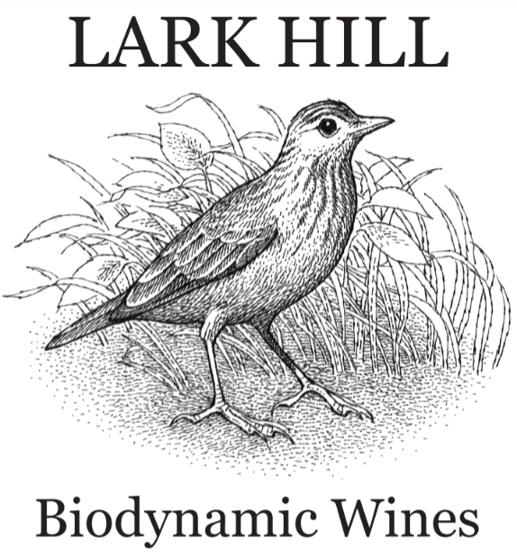

SUNDAY 10th APRIL | 12:00 PM
The Horse Rug Whisperer Novice 2.2 - AOR | 1st- 8th
The Horse Rug Whisperer Novice 2.3 - AOR | 1st- 8th
The Horse Rug Whisperer Novice AOR Champion | Chp & Res | Champion horse required
Jacqui Melbourne Art FEI Intermediate I | 1st- 8th | 1st - 3rd AOR, Pony, YR
Horsezone FEI Small Tour Champion | Chp & Res | Champion horse required
Jacqui Melbourne Art FEI Intermediate B | 1st- 8th | 1st - 3rd AOR, YR
Lark Hill Winery FEI Medium Tour Champion | Chp & Res | Champion horse required
Jacqui Melbourne Art FEI Grand Prix | 1st- 8th | 1st - 3rd AOR, Pony, YR
Donges IGA FEI Big Tour Champion | Chp & Res | Champion horse required
Equinade FEI Pony Champion | Chp & Res | Champion pony required
Bluefields Dressage & Training Center FEI AOR Champion | Chp & Res | Champion horse required
Emcee Apparel FEI Young Rider Champion | Chp & Res | Champion horse required

SUNDAY 10th APRIL | 2:00 PM
Conquerer Milling CU Preliminary 1.1 - Horse | 1st- 8th
Conquerer CU Preliminary 1.2 - Horse | 1st- 8th
Conquerer Milling CU Preliminary Champion | Chp & Res | Champion horse required
Riverina Stockfeeds CU Preliminary 1.1 - Pony | 1st- 8th
Stance Equitec CU Preliminary 1.2 - Pony | 1st- 8th
Parkes Farm Centre CU Preliminary Pony Champion | Chp & Res | Champion pony required
Kaila Simms Dressage Novice 2.2 - Young Rider | 1st- 8th
LFG Academy Novice 2.3 - Young Rider | 1st- 8th
Pepper Tree Farm Equine Clinic Novice YR Championship | Chp & Res | Champion horse required
Dressage Plus Elementary 3.2 - Open | 1st- 8th
Flexible Fit Elementary 3.3 - Open | 1st- 8th
Equinade Elementary Championship | Chp & Res | Champion horse required
Riverina Stockfeed Elementary 3.2 - Pony | 1st- 8th
Riverina Stockfeed Elementary 3.3 - Pony | 1st- 8th
The Meadowbrook Lisa Marie Elem Pony Champion | Chp & Res | Champion pony required
Horses at Home Medium 4.2 - AOR | 1st- 8th
Stance Equitec Medium 4.3 - AOR | 1st- 8th
Horsezone Medium AOR Championship | Chp & Res | Champion horse required
Dressage Plus Medium 4.2 - Young Rider | 1st- 8th
Horses at Home Medium 4.3 - Young Rider | 1st- 8th
Megan Bryant Equestrian Medium YR Championship | Chp & Res | Champion horse required
Gaultys Senior Rider | Winner
Gaultys Senior Horse | Winner | Winning horse required
Britt Grovenor Photography Off the Track Award | Winner | Winning horse required
Jindalee Stock Horses Australian Stock Horse Award | Winner | Winning horse required

